**Personal Contributions to the Development of a Python API for Image Model Training, Testing, and Deployment**

**By Joseph Fernando**

**Introduction**

During development, I took the role of technical lead, outlining the scope and implementation of this project, and taking a prominent role in its development. The scope of this project included a library of preprocessing methods, a hyper parameter optimizer, a framework for training, testing and validation of image classification and generation models, and a supporting API. Overall, the project fulfilled its purpose of significantly reducing the development time for creating a given image classification or generation model on an arbitrary dataset, as evident by the various image classification, segmentation and generation models created using the framework.

**Personal Contribution**

I outlined the requirements and contributed to the preprocessing library, which included various methods to assist in image augmentation and normalization, such as adaptive thresholding or greyscale conversion. I implemented the dataset loader, which included methods to load datasets of various types, such as images in a folder or in ubyte format, and augment/normalize it. I implemented the image generation training and demonstration. I implemented the basis of the API to utilize the functions we developed and contributed to its implementation and design.

**Results**

Using the framework and hyperparameter optimizer developed, I successfully trained a CNN classification model that achieved 95% accuracy on the CIFAR-10 dataset. Additionally, I successfully trained other classification models on datasets such as MNIST or flowers, demonstrating the framework’s functionality for general models and datasets. Finally, I created an image generation model that successfully produced flower-like images, as shown below.

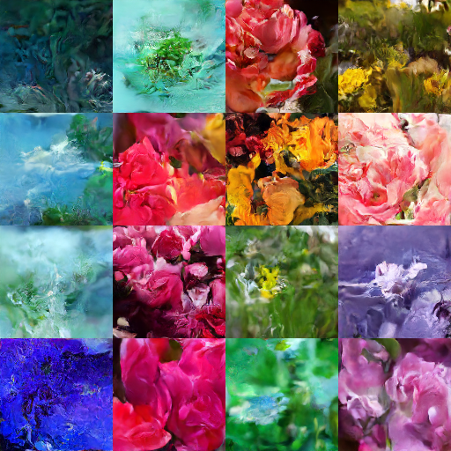

**Learning and Impact**

Overall, I learnt more about the implementation, design and theoretical underpinning of image classification and segmentation models. I learnt more about the implementation and designs of APIs. The ad hoc design of the project gave me a better understanding of the importance of a comprehensive plan before implementation. Finally, I furthered my understanding of project management, including managing a GitHub repo and allocating and distributing tasks.

**Conclusion**

This project provided valuable insights and practical experience in the design, development, and deployment of image processing and model training frameworks. By successfully building a comprehensive framework that streamlined the creation and optimization of image classification, segmentation, and generation models, I was able to address the challenges of developing machine learning models on diverse datasets. My contributions to the preprocessing library, dataset loader, image generation training, and API implementation were critical to the project's success. The results achieved, including 95% accuracy on the CIFAR-10 dataset and the generation of flower-like images, demonstrated the effectiveness and versatility of the framework. Through this experience, I deepened my knowledge of machine learning models, APIs, and project management, and learnt the importance of thorough planning and collaboration.